Fitchburg State University

CSC 7014 Practice Computer Programming

Instructor: Nguyen Thai

Due: 10/21/2016 at 5:00 PM

Student:

**CSC 7014 Assignment 6: Palindrome**

The purpose of this assignment is to learn how to program string manipulation. Your program is to be written in the Python language. You will be graded for output correctness, code comments, code indentation, descriptive variables and source code file header completeness.

As you work through the assignment be sure to answer all questions (type your answers into this document) and take all screenshots as requested (copy them into the document). For the screenshots, you can use the Snipping Tool that is built-in to Windows to capture the important parts of the lab as highlighted in the document below. Do not delete the contents of this file. When finished, you will submit the document source code file and associated data files to the instructor via Blackboard. DO NOT SUBMIT ZIP FILES OR INDIVIDUAL IMAGES. If you have any questions or need any clarification, email the instructor *before* the deadline.

1. In this lab you are to write a program in Python called *palindrome.py* to implement the checking of a palindrome string.
2. A string is a palindrome if it reads the same forward and backward. The words “mom”, “dad” and “noon” for example, are all palindromes.
3. You are to write a function called isPalindrome() that
   * Takes in a string
   * Return True if the string is palindrome
   * Return False if the string is not palindrome
4. Here are your test cases:
   1. “madam”
   2. “moon”
   3. “Was it a cat I saw”?
5. Before coding, think how you are going to tackle this problem, and write a short description of the logic of your program.
6. **INSERT YOUR DESCRIPTION HERE.**
7. Firstly, we define the function named isPalindrome() which takes string”s” as in parameter. Inside this function we convert the string into lower case by using lower () and removed the whitespaces between the strings using replace ().
8. Next, we reverse the given string using the slicing operator[::1] and stored the reversed string into variable named rev_s.
9. We used if statement to check whether the given string and the revered string match or not. If the string is a palindrome, then it returns True otherwise returns False.
10. To test the given test cases, we defined one more function named testPalindrome () which takes two parameters “s” and “expectedResult”. Inside this function we called the function isPalindrome and stored the result value in variable named actualResult.
11. Next, using the if statement we compared the actualResult and expectedResult. If both matches, then the test is passed otherwise test is failed.
12. Finally, in the test case we call function testPalindrome() by providing the string and the expectedResult value.
13. **TAKE A SCREENSHOT** of your input and output, and paste them here. Do not paste your source code in this document.

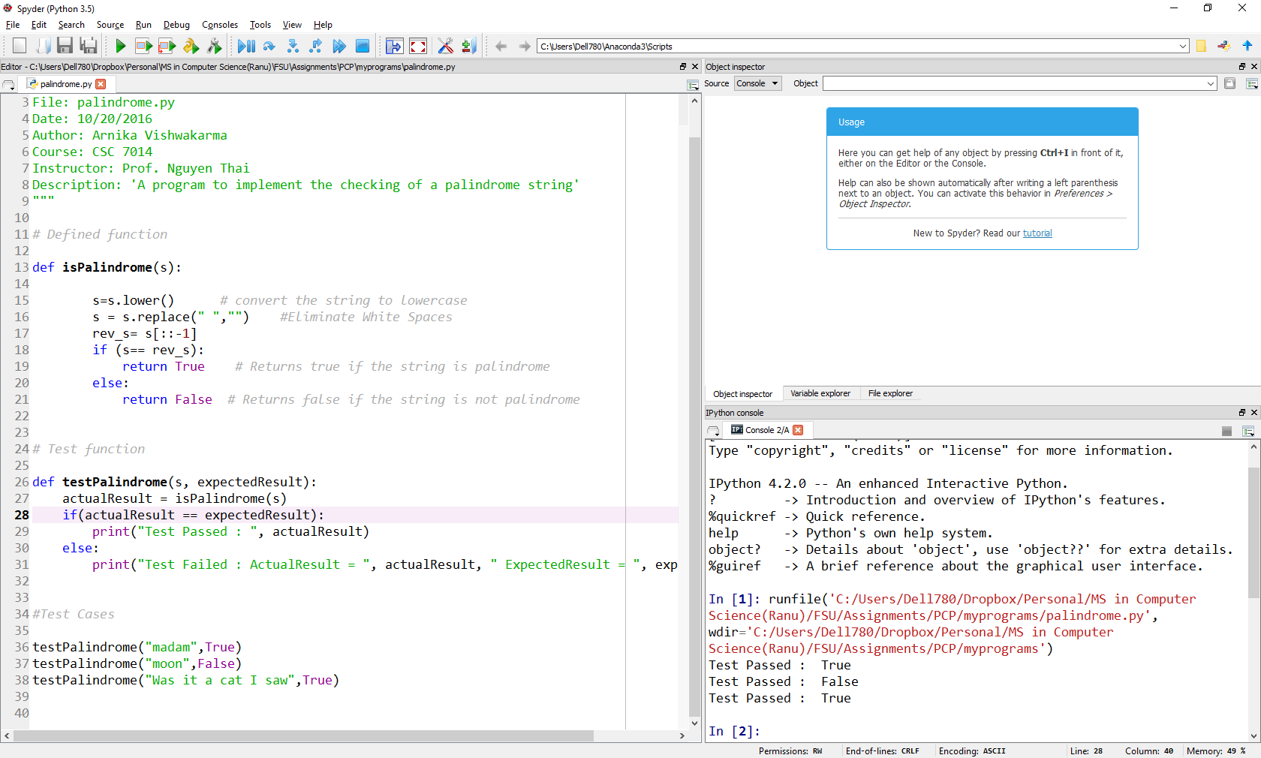

1. Submit your source code and this document to Blackboard for grading.